Extracting Comparators from Comparable Questions using Data Mining

A project presented to the
Department of Computer Science
University of Nebraska at Omaha

In Partial Fulfilment of the Requirements for the Degree

Dec 18th, 2016

SUPERVISORY COMMITTEE
Dr. Zhengxin Chen (Chair)
Dr. Sanjukta Bhowmick
Dr. Abhishek Parakh

PREPARED BY
Jalan Macherla

Abstract

Comparing a thing with another is the usual tendency of human beings in the decision making process, but it is difficult to know the alternatives because of the limited knowledge. This way of comparing things is very common in our daily life. That being said, a novel strategy is implemented to automatically mine comparable entities from the comparative questions which user present online. The proposed system improves the efficiency of mining comparators by adapting a weakly supervised boot strapping algorithm. The bootstrapping algorithm used helps us in achieving high precision and recall. The primary intention is to mine comparative entities from the comparative questions, and before that identify the questions provided by the user is a comparative question or not. The proposed system extracts the entities from the comparative questions once the algorithm identifies the question as the comparative question and presents the user with possible alternative options. The trial and error final results present that the approach achieves F1-measure associated with 82.5 percent in comparison question identification in addition to 83. 3 percent in comparable entity extraction.

Contents
Abstract 2
1. introduction: 4
1.1 Objective 5
1.2 Deliverable 5
1.2 Research Question(S) 6
1.3 Challenges Faced 6
1.5 Main Reference / Contribution 6
2. LITERATURE REVIEW 9
2.1 Identifying Comparative Sentences in Text Documents 9
2.2 Mining Comparative Sentences and Relations 10
2.3 Mining Knowledge from Text using Information Extraction 10
2.4 Learning Surface Text Patterns for a Question Answering System 11
2.5 Relational Learning of Pattern-Match Rules for Information Extraction 12
2.6 Comparable Entity Mining from Comparative Questions 12
3. academic value 14
3.1 Information Storage & Retrieval 14
3.2 Database Management System 14
3.3 Software Specification & Design 15
4. High level details 16
4.1 Block Diagram of the Project 16
4.2 Program Flow 17
4.3 Requirements 18
4.3.1 Hardware Requirements 18
4.3.2 Software Requirements 18
5. IMPLEMENATATION 19
5.1 Design Artifacts 25
6. EXPERIMENTS COnDUCTED & ANALYSIS 29
7. CONCLUSION 30
8. Future work 31
9. REFRENCES 32
10. APPENDICES 33

introduction:

Selection of a thing among several available options is decisive in nature, but to have options prior to selection is of interest. Sometimes we have many options, sometimes we have none, and sometimes it is limited to a few. Users usually compare entities for selection. Comparing entities having a common utility but with distinguished features is decision making. When we search for a thing in a search engine, we get the results which are related to the search query, we find links to the website where our query term is used, and we find images and so on. But, it’s hard to find what would be alternatives to your search query. For example, if you search for an iPhone, you get all the results that are related to iPhone, but nowhere you find that a blackberry or a Nokia displayed in the search results, this is because the query term is not related to them. What if you want to find an alternative to iPhone? Yeah, you can answer this, as almost everyone knowns an iPhone. What if I ask you, what are alternatives to Statin?
So our architecture attains the objective of extracting many relevant things from the users who post questions online. The main components of decision making process are the comparative questions and the comparators in that question.
Comparative questions: A question intended to compare entities of similar types.
Comparators: Entities in the comparative questions which are to be compared.

It is difficult to decide whether two entities can be compared or not. A question posted necessarily need not be a comparative question. For example, which city is good, this is not a comparative question, is Omaha best city? Even this is not a comparative question. Which city is better Omaha or Lincoln, this is a comparative question as we are trying to compare two cities in the above example. Here Omaha and Lincoln act as comparators.

Our primary intention is to mine the comparators from the comparative questions and suggest alternatives from the previous online user’s request. Knowing popularity of comparators among the users will be very helpful to companies to know their competitor.

Objective

The objective of this research is to present a novel way to mine comparative entities from comparative questions that users posted online to address this issue. Weakly supervised bootstrap algorithm is used to ensure high precision and recall, through a large collection of online archives. Very high F1 score is achieved during this process.

1.2 Deliverable

The application which would be developed would help users in finding alternatives to their entity. The users can post a question online and find the answer to it from the questions archive already present in the database and build a comparator sets based on it. The alternatives provided by the application would be ranking based, highest being displayed at the top.

Research Question(S)

- Know the existing approach and the previous approaches and knowing their drawbacks and researching on those drawbacks.
- Knowing the concepts of association rules and how they can be wisely used in the project to help in decreasing the ambiguity.
- How to store the raw data and how to make useful information from that raw data?
- Investigate in pattern evaluation and pattern generation for identifying the comparative question.

Challenges Faced

- The most important challenge faced by me is to understand the existing algorithm and implement my ideas to achieve higher precision and recall.
- Finding online questions and manually answering them, so that it is saved in the database.
- Implementation of the bootstrap algorithm.
- How to resolve the ambiguity during answering the comparative questions?

1.5 Main Reference / Contribution

Comparable Entity Mining from Comparative Questions by Shasha Li, Chin-Yew Lin,
Young-In Song, Zhoujun Li is the main paper which I have referred in coming up with my project. I have used the existing procedure used in the main paper, and enhanced it. I have altered the bootstrapping algorithm in order to attain high precision and recall and overcome the drawbacks of the main paper.
The following is the detailed major differences and enhancements compared to the main reference paper and my research.

The main reference paper attained high precision and recall compared to the initial existing system which was proposed by Jindal and Liu

Suggesting the user alternatives of a word / entity. User who has no prior knowledge of the alternatives to an entity has to simply enter the entity and the proposed system takes care of suggesting him the alternatives to that particular entity The proposed algorithm traverses the databases and through the questions and finds the frequent alternatives, the most frequent being displayed at the top.

Changed the boot strap algorithm, minimizing the data selected initially with only selective comparative question which makes the proposed system more adaptive when a new comparative question is posted to the system.

The most important part of my contribution is using of the association rules. I have used the association rules making use of the support and confidence in making the output make more correlated, frequent entity pair comparison after the boot strap algorithm. This helps in determination of relationship between comparable entities.

Graphical representation of the most keyed words from the user perspective. This helps the user in finding his nearest rivals as per the internet search to be precise our proposed system search.

LITERATURE REVIEW

Identifying Comparative Sentences in Text Documents

Comparisons can be subjective or objective. It’s more like comparing one object with another, for example, this city A is much better than city B. This paper studies how to identify comparative sentences. The paper clearly addresses the problem of identifying the comparative sentences. The approach first categorizes comparative sentences into different types and then presents integrated pattern discovery in identifying comparative sentences from text documents. The classification of sentences into comparative and non-comparative is the basic idea of the paper.
The approach takes into account of the Class sequential rules [1] in building the learning model. The basic approach followed is the combination of the class sequential rules and machine learning. Use of machine learning methods to overcome the previous drawbacks is used in distinguishing comparative and non – comparatives. The paper has taken into account of the user preferences and implicit comparators also. The way of extracting comparative sentences from the text based is used in many applications. The main disadvantage is that it suffered from low recall though high precision was attained.

Mining Comparative Sentences and Relations

The basic idea of the paper is to have comparative relations from the already identified comparative questions. One way to evaluate an event is to compare with similar event. Class sequential rules and label sequential rules [8] are used to accomplish the above task. From the input, they identify the comparative sentences and classify the identified comparative sentences into different classes. After that extract comparative relations which involve extraction of entities and their features that are being compared and comparative keyword. The main idea of the paper hovers around the basic agenda, the way of evaluation is to compare with similar entity. It suffered from low recall, though the precision is reasonably high.

Mining Knowledge from Text using Information Extraction

Paper discusses about use of two approaches in natural language information extraction for text mining. The first is extraction of general knowledge directly form the text and the second one is to first extract the structured data from the unstructured data or the semi structured data by applying traditional knowledge discovery in database methods [4]. Supervised machine learning methods were preferred than the manually developing patterns as the machine learning method is successful in developing robust information extraction systems. Many IE systems simply treat text as sequence of tokens however many others treat them other tools like POS, learned extraction rules [5], phrase chunkers to identify phrases to extract [6], others use lexical semantic databases, as WordNet [7].
The whole paper revolves around extraction of information which is structured in nature from unstructured data or semi structured data. The main disadvantage is that it cannot meet the demand of the ever increasing corpus.

Learning Surface Text Patterns for a Question Answering System

Open domain question and answering systems use external knowledge and tools for answering [3]. A fairly list of surface patterns was a way to evaluate them. Certain type of answers is expressed using characteristic phrases, authors try to automatically acquire patterns and try to measure the accuracy of the patterns. Pattern learning algorithm is described by constructing a pattern for each individual question type.
The algorithm is to select an initial example and search for it in a search engine and select the top thousand results and apply a sentence breaker to the selected documents. In the selected documents retain only those sentences that contain both the question and answer term, then remove the tags, tokenize the input and pass the retained sentence through suffix tree constructor. Lastly pass each phrase through filter and retain only those phrases / sentences which contain both question and answer. The proposed system assumes that each sentence is a simple sequence of words. The disadvantage of the system is it doesn’t make a clear distinction between lower and upper case.

Relational Learning of Pattern-Match Rules for Information Extraction

Information extraction systems are difficult and time consuming to build and they are domain specific and its complex to port to new domains. Robust Automate Production of Information Extraction [2] system proposed learns rules for the complete information extraction. The resulting rules extract the desired items directly form the text without parsing or processing. The learning algorithm primarily consists of specific to general search of patterns. First most specific patterns are created for each example. Pre filler contains item for each word from the beginning of the document to the word immediately preceding the filler. Now RAPIER attempts to compress the specific rules and try to generalize them, initially it takes two rules and tries to create a general one. RAPIER system uses relational learning to construct unbounded pattern match rules for information extraction.

Comparable Entity Mining from Comparative Questions

In the World Wide Web era comparison involves search of the term in the web, scan through the pages, find reviews and so on. The paper focuses on finding the alternatives to a word. The comparators are mined from the comparative questions. If some user is posting a question which has tries to find the relation between two words, then that means that the user is trying to find the relation between those two entities. We simply rely on this search from the user in finding comparative entities.
What can be compared and what cannot be compared, how to identify whether the question supplies are comparative question and how to retrieve the comparators without comprising on precision and recall is the main idea of the paper.

The authors use the boot strapping algorithm to overcome the drawback of the previous approach proposed by Jindal and Liu [1] which lags in low precision and recall in entity mining. Their approach is using Class sequential rules and Label sequential rules. The proposed system makes three kinds of patterns in evaluating whether a given user question is comparable or not. It uses Lexical patterns, Generalized patterns and Specialized patterns. The boot strapping algorithm process starts with a single IEP (indicative extraction pattern), from it set of initial seeds of comparator pairs are extracted. All the questions which contain these comparator pairs are considered as comparator questions. All the reliable ones are added to IEP repository. In the paper they have presented a weakly supervised method to identify comparative questions and extract comparators

academic value

My course work at College of Information Science and Technology at University of Nebraska, Omaha, and internship at Election System and Software, and last at present work CSG International helped me gain sufficient knowledge. I have learnt a lot during the school, my concentration was databases, and the following courses helped me successfully implementing my project Comparable Entity Mining from Comparative Questions [1]

3.1 Information Storage & Retrieval

How to store the information and effectively retrieve the stored information, how to use the association rules which is a major enhancement to the project by aptly making use of support and confidence in retrieving the desired results, this course has helped me in achieving these. These concepts learnt in the course laid a strong foundation for proposed project. The main important part the course which has helped me in the project is the information extraction.

3.2 Database Management System

Efficient storing of the data and retrieval is important to any project. My concentration is databases and I have taken three courses in this concentration and all of them equally helped me. My project always deals with the data and its storing, as the storage keeps on increasing data model should be built to handle such increasing load. This course has taught me all the basic database requirements I should keep in mind before designing. This course has helped me to understand concepts like relational models, data modelling, SQL, database administration and security, database design, normalization and so on.

3.3 Software Specification & Design

This course has helped me to understand the early phases of software development, particularly requirements gathering. I also understood the different phases of Software Development Life Cycle. This course also helped me in read and write formal specifications of any existing software’s used during the project. The success of any software project depends on efficient planning, creating, testing, and deploying. The Software Requirements Specification document that I created for a project that I did in this course helped me to describe the software system being developed, to list the functional and nonfunctional requirements. It helped me to visualize what the system is supposed to do and not to do. It also helped me to plan, identify risks and estimate costs. Apart from the understanding the various requirements during the development cycle this course helped in creating documentation for an application or a project.

High level details

4.1 Block Diagram of the Project

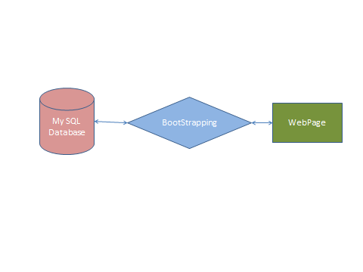
Fig 1. Block diagram of the project

The above block diagram represents overview of the proposed project. The users access the webpage, users can search for comparators or comparator questions. Webpage through the server reaches the database. The bootstrap algorithm does the necessary processing and stores the data in the data base based on the user input / query. The database stores all the information regarding the users, admins, and their querying. Though both the user and administrator can answer the questions, it is only the administrator who can authorize the database directly and manage, maintain it.

Program Flow

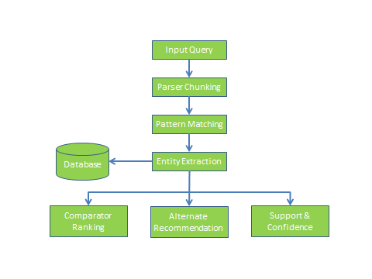
- Take input from user.
- Check whether the input question is a valid question or not.
- If it’s a valid question, then the regular process should follow.
- Match the input with the existing and extract comparators from them.
- Extract comparators from the comparative questions.
- Suggest user with alternatives for a give input.

4.3 Requirements

4.3.1 Hardware Requirements

- System : Pentium IV 2.4 GHz.
- Hard Disk : 40 GB.
- Floppy Drive : 1.44 Mb.
- Monitor : 15 VGA Colour.
- Mouse : Logitech.
- Ram : 512 Mb.

4.3.2 Software Requirements

- Operating system : Windows XP/7.
- Coding Language : JAVA/J2EE
- IDE : Eclipse
- Database : MYSQL

IMPLEMENATATION

The application is designed using web technologies (html, css and JavaScript) for user interface and input validation. Java technologies are used (servlets, jsp and jdbc) for dynamic application logic processing.
There are two users in the application
1) Administrator
2) Users.
Application allows administrator to login and load dataset, once after loading dataset application applies comparative question identification technique called IEP to find out comparative questions from loaded dataset. Admin can add new questions manually and can give answers to those questions and the same can be done by users also. Manually added question and their answers will be saved in MySQL database.

Dataset Information
The dataset used for the application is downloaded from yahoo answers site called ‘Yahoo Research Alliance Web scope program’. This dataset contains nearly 6000 questions and answers and we will take only comparative questions from 6000 questions by applying IEP technique.

Program Details
Load.java: This program is invoked to read the path of uploaded dataset. User will first choose dataset directory and upon clicking on a button user interface will call Load program to read the path of selected dataset.
ReadQuestions.java: This program will be invoked by Load program to read questions from loaded dataset. This program read all questions from dataset and stored in java JVM memory for further processing.
PosTagger.java: This program read all questions from JVM memory store by ReadQuestions program. After reading each question this program will apply following technique to determine given question is comparative or not.
Lexical patterns: These patterns indicate sequential patterns consisting of only words and symbols ($C, #start, and #end).
Example: Which is better, Omaha or Lincoln?

Generalized patterns: A lexical pattern is too specific for matching. Lexical patterns are generalized by replacing one or more words with their POS tags.
Example: Which city is better, Omaha or Lincoln?

Specialized patterns: Pattern specialization by adding POS tags to all comparator slots.
For example, from the lexical pattern “<$C or $C>” and the question “Omaha or Lincoln?”, “<$C=NN or $C=NN?>” will be produced as a specialized pattern.
Example: Omaha or Lincoln?

TagWord.java: Using this program we are assigning Part of Speech tag to each word available in a question.

Phrase Chunker: Generate sequence for the comparative question. If the IEP is a pattern without generalization, we just need to tokenize the questions and the sequence is the list of resulted tokens. Otherwise, phrase chunking is necessary. The sequence is a list of resulted chunks. Take the question “Which is better phone iPhone or nokia n95?” for example. If we apply the pattern “Which is better $C or $C?” to the question, we generate a sequence “which|is|better|phone|iphone|or|nokia|n95|?” If we apply pattern “Which is better NN $C or $C?” to the Question, a sequence “Which/WP | is/VBS| better/ JJR|phone/NN|iphone/NP|or/CC|nokia n95/NP|? /?”. Check whether sequence of the question matches the given pattern. If IEP is a specialized pattern, the POS tag sequence of extracted comparators should follow the constraints specified by the pattern.

Rules for Phrase Chunker

/* * Heuristic rules
* NP* -> NP
* NN* -> NN
* NN + NNS -> NNS
* NP + NPS -> NPS
* More + ADJ -> JJR
* Most + ADJ -> JJS
* ...
*/
Search.java: This program read input from user and checks weather given input is comparative or not by applying above technique and if question comparative then application suggest all related answers for given comparative questions and all answers previous user search for same or other comparative questions

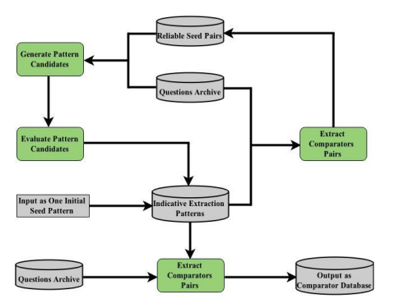

Boot strapping is a method for comparative question identification and entity extraction from those comparative questions from users input. Pattern generation makes use of Lexical, Generalized and Specialized patterns.
The following are the steps followed and are clearly depicted in the picture above also.
- Process the input
- Match the input with existing one from the database
- Identify comparative and non-comparative questions
- Extract the pairs on entities from the comparative questions.

A question is said to be comparative question if it matches Indicative Extraction Pattern,
And the tokens are extracted as comparators [9]. For a question to be a comparable question, it has to be matched with the following types.

Lexical patterns: These patterns indicate sequential patterns consisting of only words and symbols ($C, #start, and #end).
Example: Which is better, Omaha or Lincoln?

Generalized patterns: A lexical pattern is too specific for matching. Lexical patterns are generalized by replacing one or more words with their POS tags.
Example: Which city is better, Omaha or Lincoln?

Specialized patterns: Pattern specialization by adding POS tags to all comparator slots.
For example, from the lexical pattern “<$C or $C>” and the question “Omaha or Lincoln?”, “<$C=NN or $C=NN?>” will be produced as a specialized pattern.
Example: Omaha or Lincoln?

Parts of speech tagger plays important role in extracting comparators [9]. Common parts of speech tags are nouns, pronoun verbs, adjectives and so on. Sometimes just depending on POS will not eliminate the unnecessary tags, we have to merge certain words to effectively extract comparators. We use phrase chunking, which is a process of marking two or more POS tags as one tag.

Once the user input is parsed, which literally means removing all the tags and extracting the entities, they are stored in the database. When a user enters search word to find the alternatives, it traverses through all the comparator questions and returns the alternatives. First if the question already exists in the database, the output would be displayed and if it is not there in the database, it is tested whether it is comparable question or not. Once the question is comparable, it extracts the comparative entities from it.

Then the comparators are ranked based on how many times they have appeared in the database and the one with the highest frequency is displayed at the top when a user searches for the alternative.

Association rules helps in neatly correlated data, with frequent entity pair comparisons. It is based on two measures, namely, Support and Confidence.

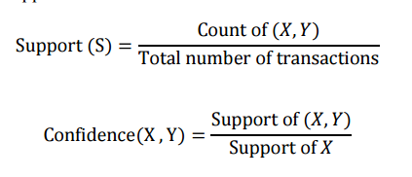
Frequent item sets are generated using the support and confidence.
First the data is scanned and support is calculated for each entity, and then frequent sets are generated. If the confidence is greater or equal to a specified confidence, then it is added to association rule, which determines the relationship between comparable entities.

5.1 Design Artifacts

Use case Diagram
Use case diagram for Admin:
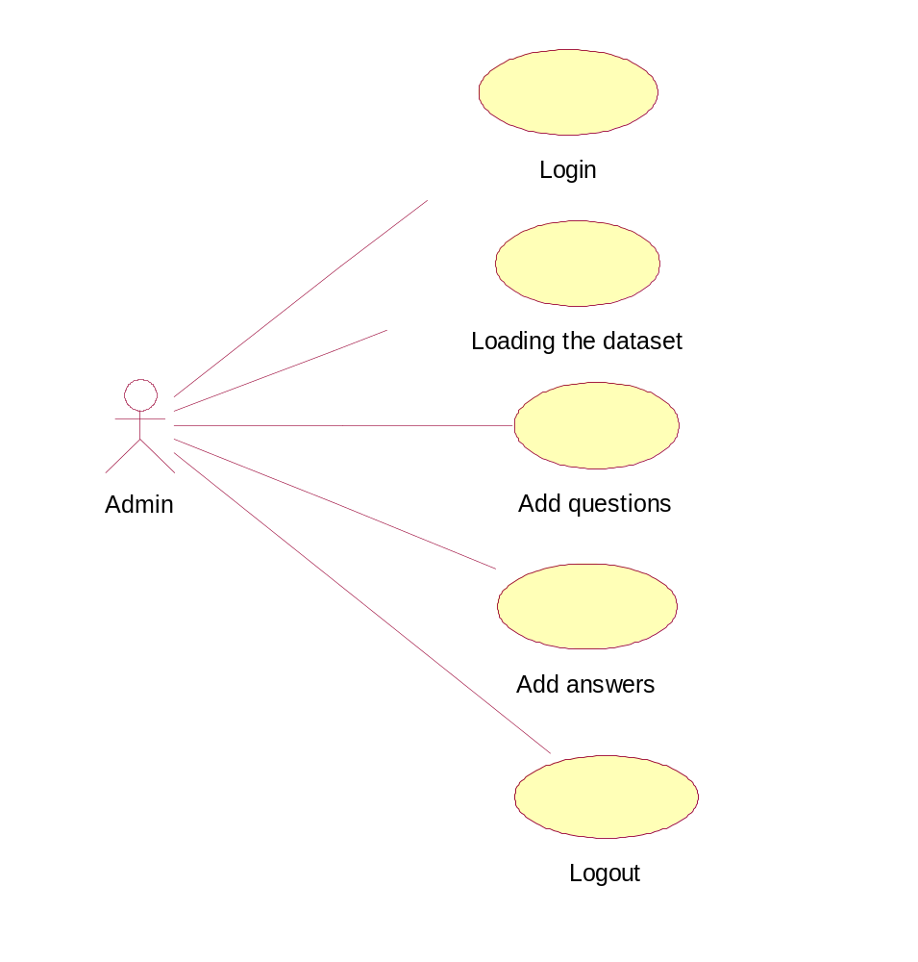

Use case diagram for user:

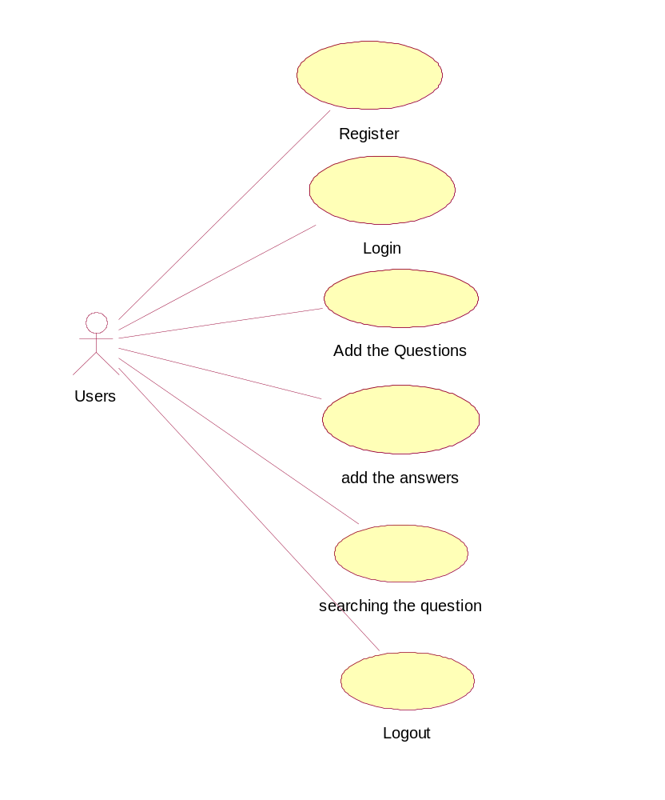

Class diagram:

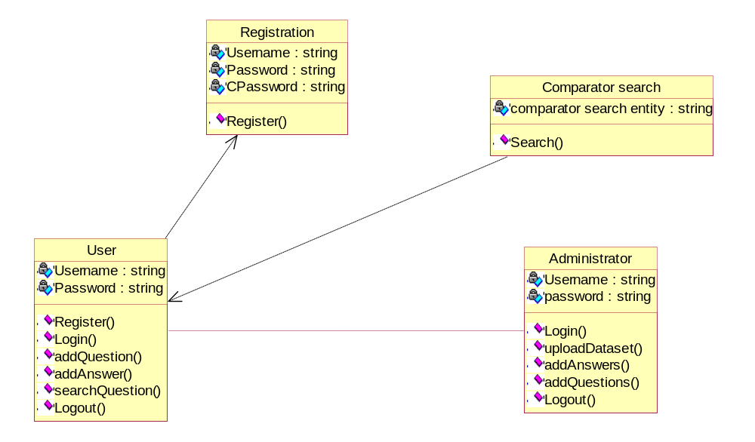

Sequence diagram:

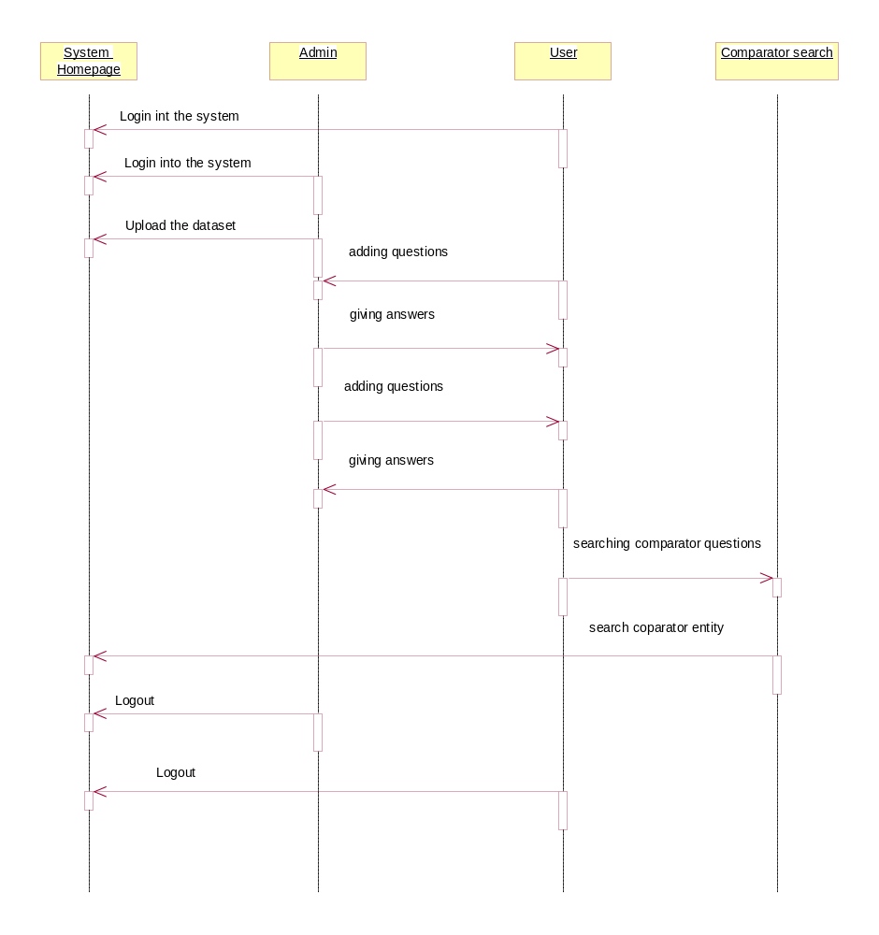

EXPERIMENTS COnDUCTED & ANALYSIS

After user enters the query, our system first lets us know whether the given question by the user is comparable or not immediately. If the question provided is a comparable one, then the process proceeds else it will display an error message saying that the question is not comparable. Now if the question passed already exists in the archive then the user will get an answer which is already there in the system and if the question doesn’t exist in the system then it will be left to the admin to answer the question. Once the question is there in the system our process stores the comparative entities. This way alternatives are recommended to the user when the user searches for the alternatives.

I have manually created an initial data set of around 150 questions and answers from Yahoo question answers. I have taken two sets Set A and Set B, Set A contains comparative and non-comparative questions from the yahoo dataset and the Set B contains only comparative questions. Calculated precision, recall and F Score for both the sets. Observed that the Precision, recall and F score are high in comparator extraction when compared to the existing system.

CONCLUSION

Implemented the bootstrap method. System identifies the comparative questions posted by the users. The system first identifies whether it’s comparable or not in the first place. The alternatives are suggested to the users who search for a particular word for which one is not aware of the alternatives. Hybrid approach is implemented by taking into account both the boot strap algorithm and the association rules. This helped in achieving high recall and the high precision. Support and Confidence are nowadays popular indicators. These techniques may be used by the competitors to know their nearest competitor in the market. Suggestion of comparable entities can assist online users in their comparison activities before making a purchase decision. The results are helpful for companies in identifying their competitors.

Future work

I would work on Ambiguity entity conflict. There are some situations where the results would result which are not of user’s intention. Some words may fall into different datasets and knowing to which dataset that particular word fits into is important in order to retrieve the correct results from the database. Since the dataset used is very small in nature, performance is good as of now. Consideration of time taken to retrieve the relevant information is very important if the data dealt with is very huge. Finally, how to effectively use the logic for acronyms to fit into datasets (like ‘CSG’, ‘AAPL’).

REFRENCES

[1] N. Jindal and B. Liu, “Identifying Comparative Sentences in Text Documents,” Proc. 29th Ann. Int’l ACM SIGIR Conf. Research and Development in Information Retrieval (SIGIR ’06), 2006, 244-251.
[2] M.E. Califf and R.J. Mooney, “Relational Learning of Pattern- Match Rules for Information Extraction,” Proc. 16th Nat’l Conf. Artificial Intelligence and the 11th Innovative Applications of Artificial Intelligence (AAAI ’99/IAAI ’99), 1999
[3] D. Ravichandran and E. Hovy, “Learning Surface Text Patterns for a Question Answering System,” Proc. 40th Ann. Meeting on Assoc. for Computational Linguistics (ACL ’02), pp. 41-47, 2002.
[4] R.J. Mooney and R. Bunescu, “Mining Knowledge from Text Using Information Extraction,” ACM SIGKDD Exploration Newsletter, vol. 7, no. 1, 2005, 3-10
[5] M. E. Califf and R. J. Mooney. Bottom-up relational learning of pattern matching rules for information extraction. Journal of Machine Learning Research, 4:177– 210, 2003.
[6] C. D. Fellbaum. WordNet: An Electronic Lexical Database. MIT Press, Cambridge, MA, 1998.
[7] L. A. Ramshaw and M. P. Marcus. Text chunking using transformation-based learning. In Proceedings of the Third Workshop on Very Large Corpora, 1995.
[8] N. Jindal and B. Liu, “Mining Comparative Sentences and Relations,” Proc. 21st Nat’l Conf. Artificial Intelligence (AAAI ’06), 2006.
[9] Li Shasha, Chin-Yew Lin, Young-In Song, and Zhoujun Li, “Comparable Entity Mining from Comparative Questions”, Knowledge and Data Engineering, IEEE Transactions on 25, no. 7, pp. 1498-1509, 2013

APPENDICES

Application Screenshots:
Index page
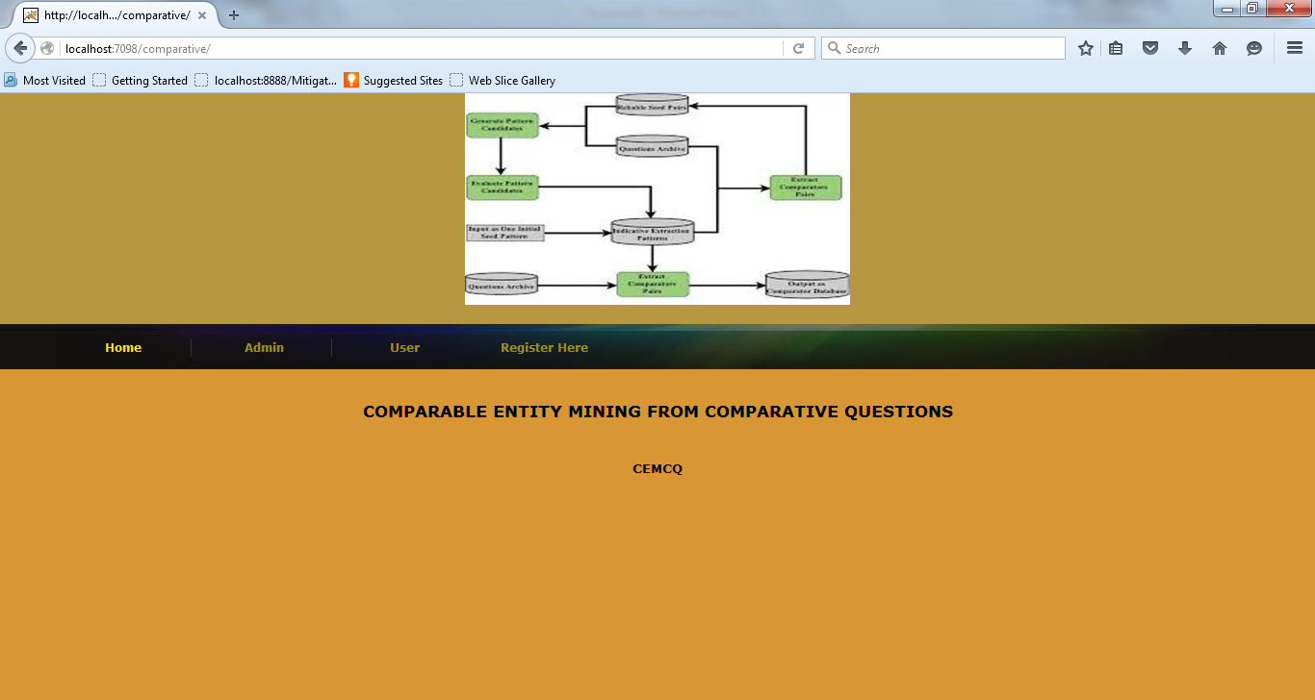

Admin Login Page

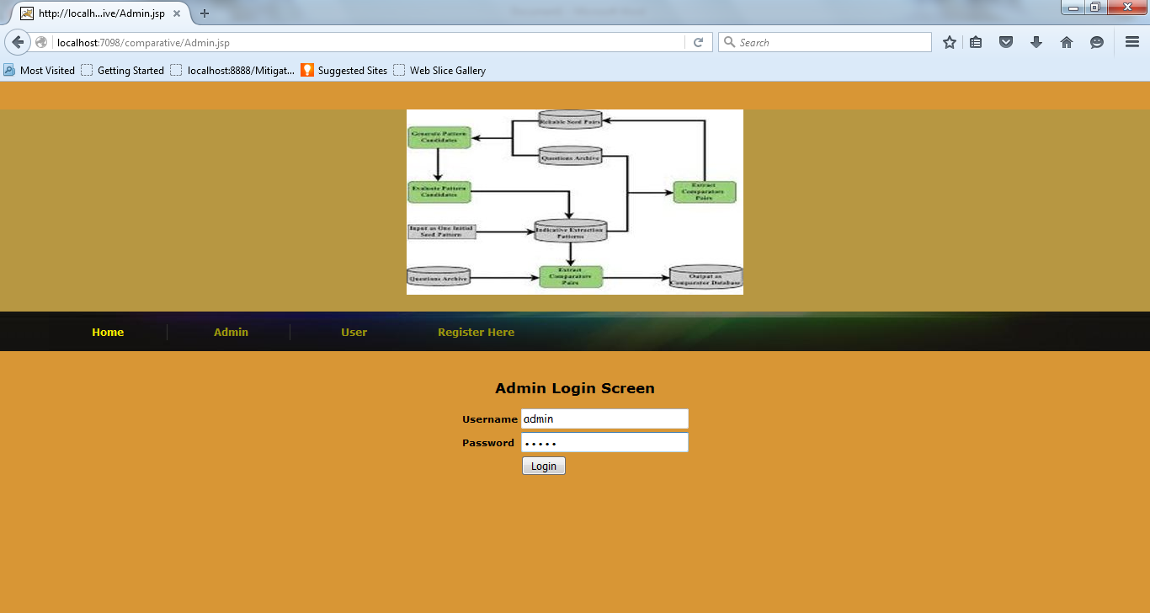

Admin Screen

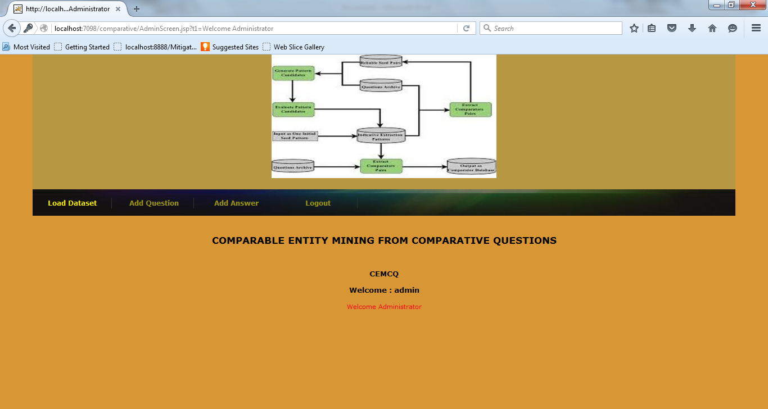

Admin to add question

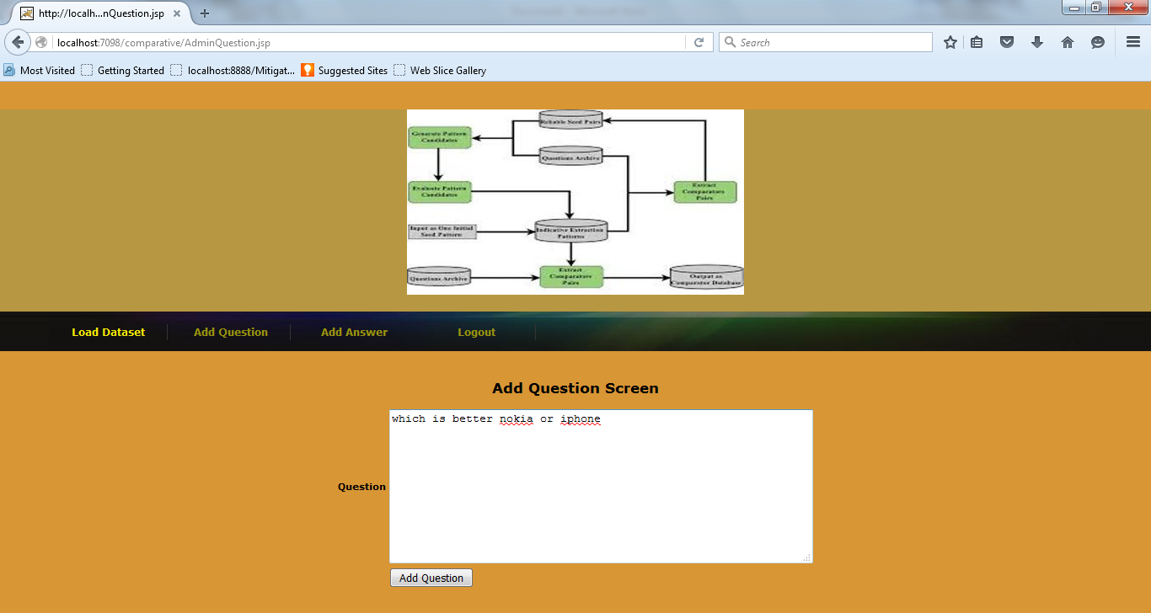

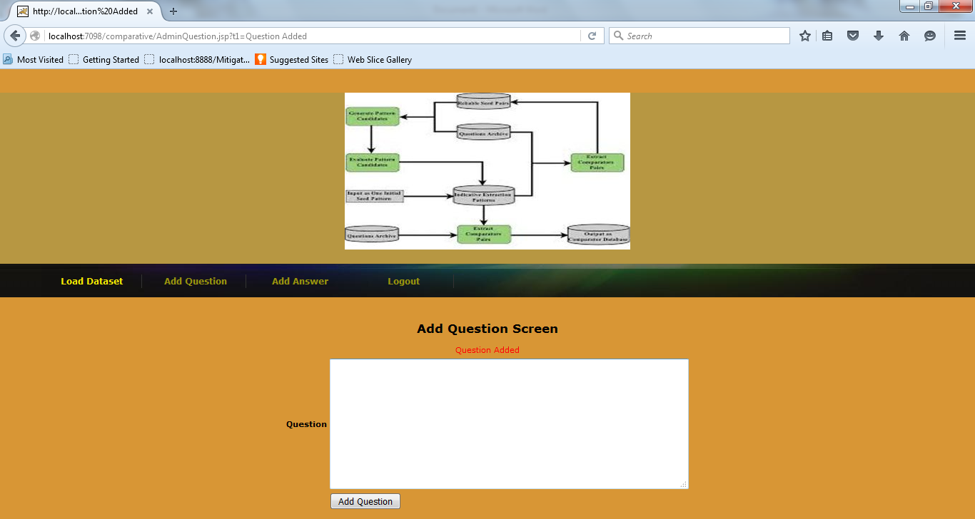

Admin to give answers

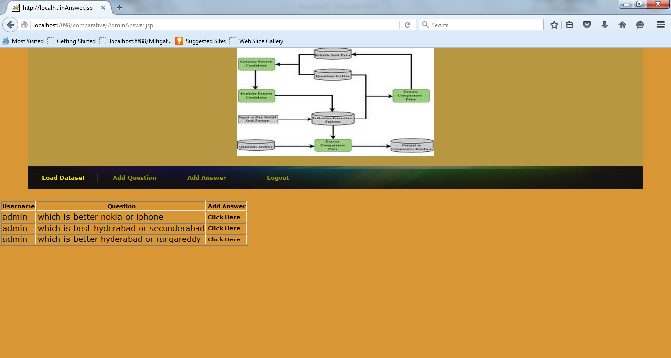

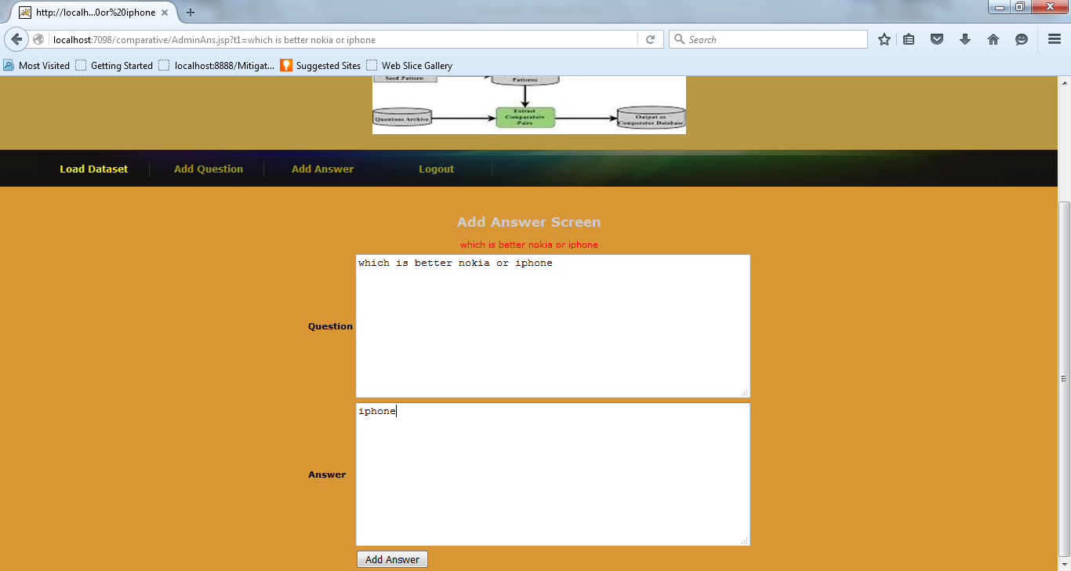

After giving answer

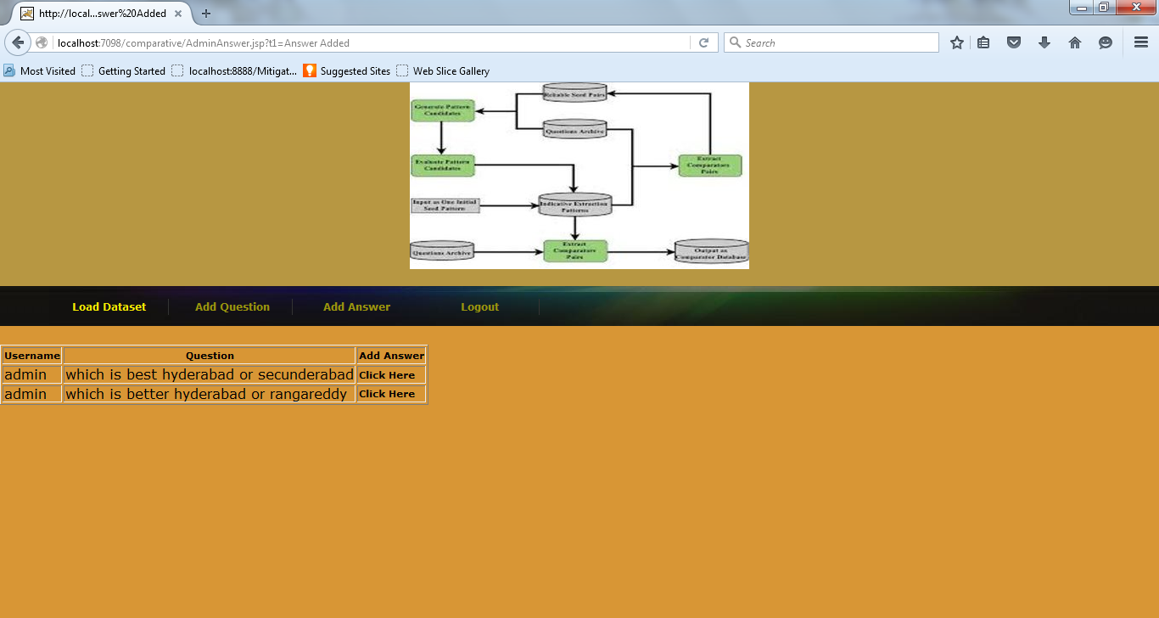

Admin to load dataset and build comparative question and answers collections

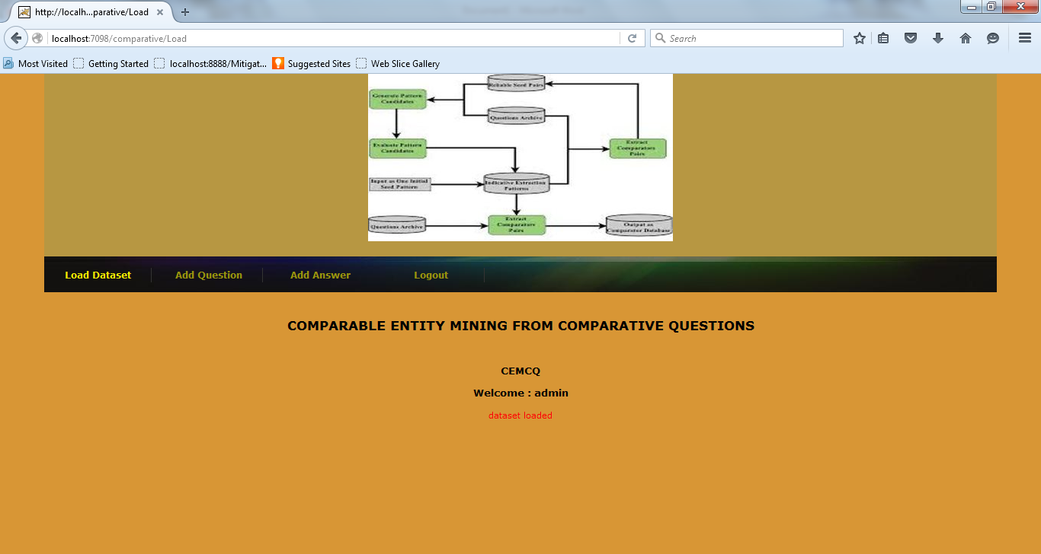
User registration screen

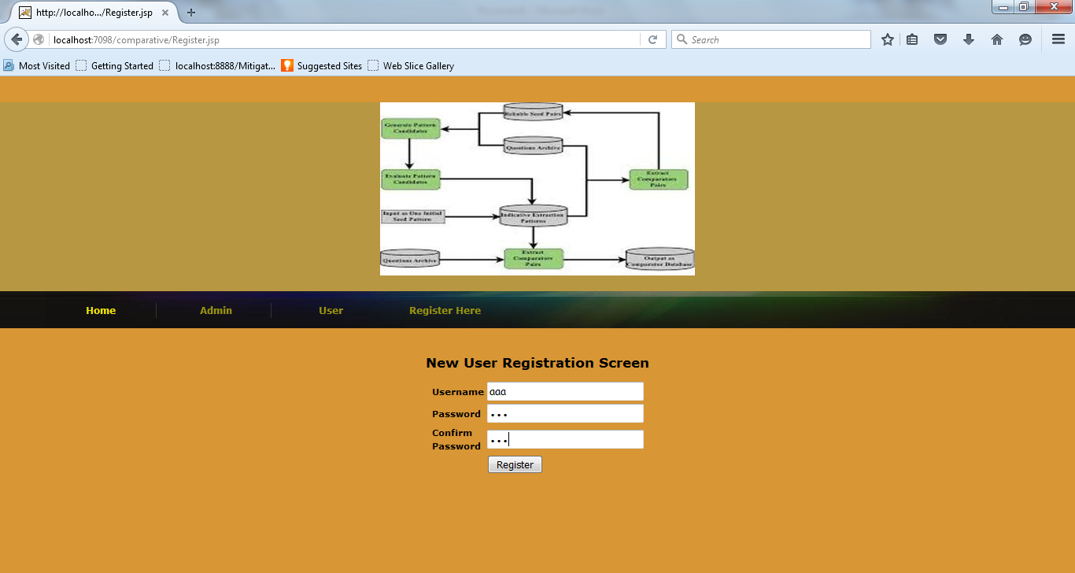

User login
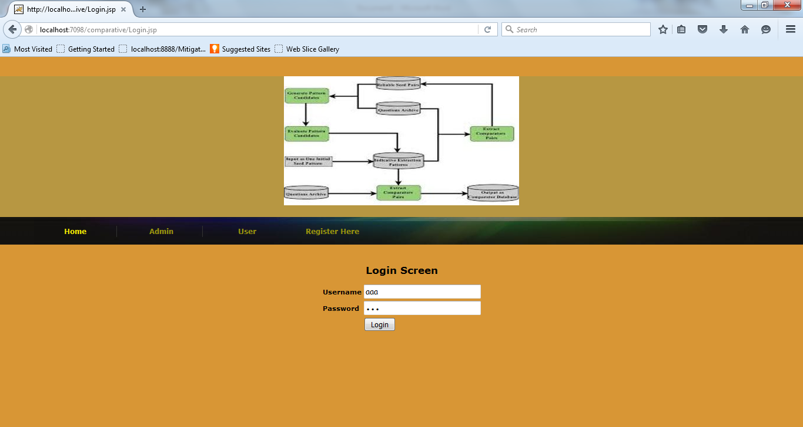
User screen

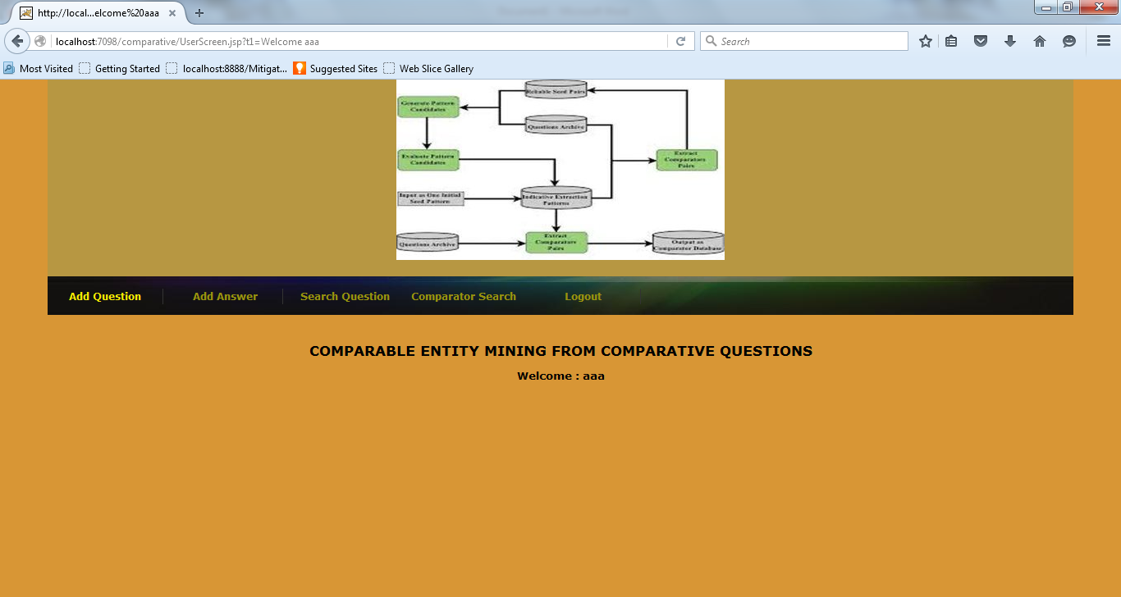

User to add question

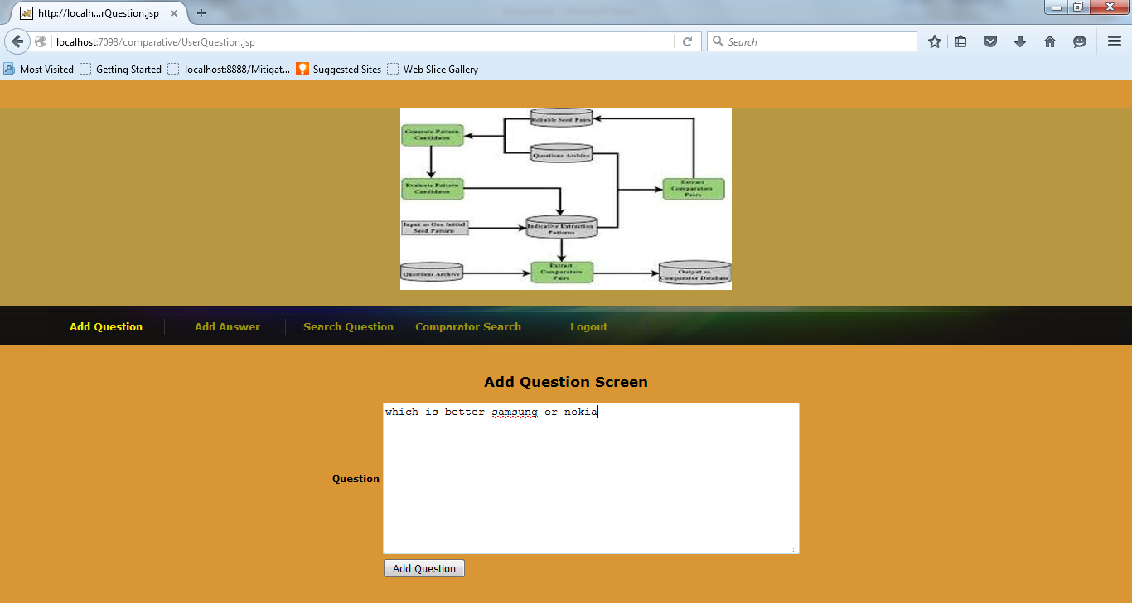

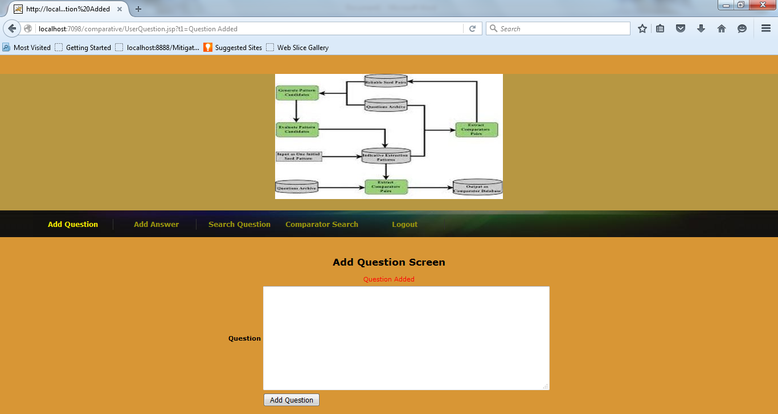

User to give answer

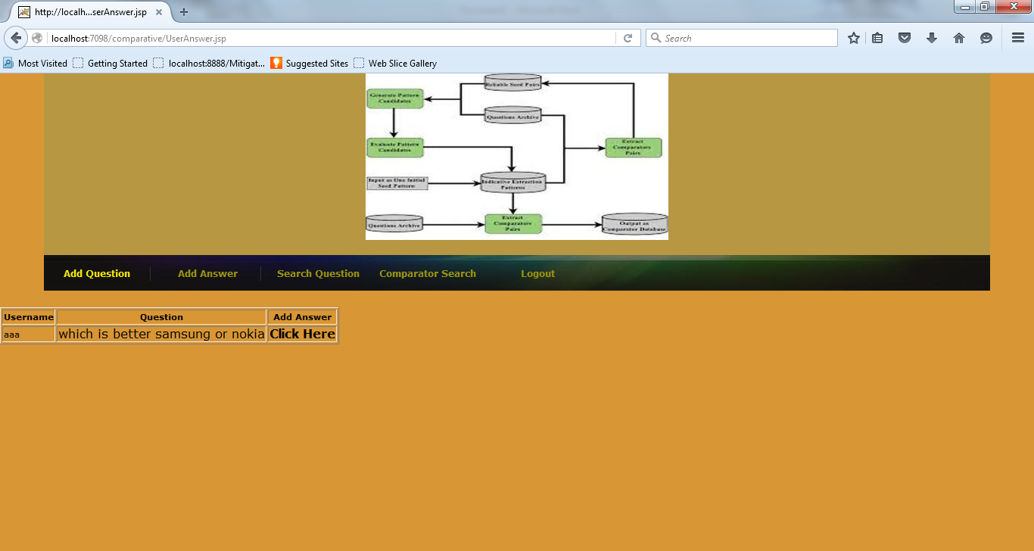

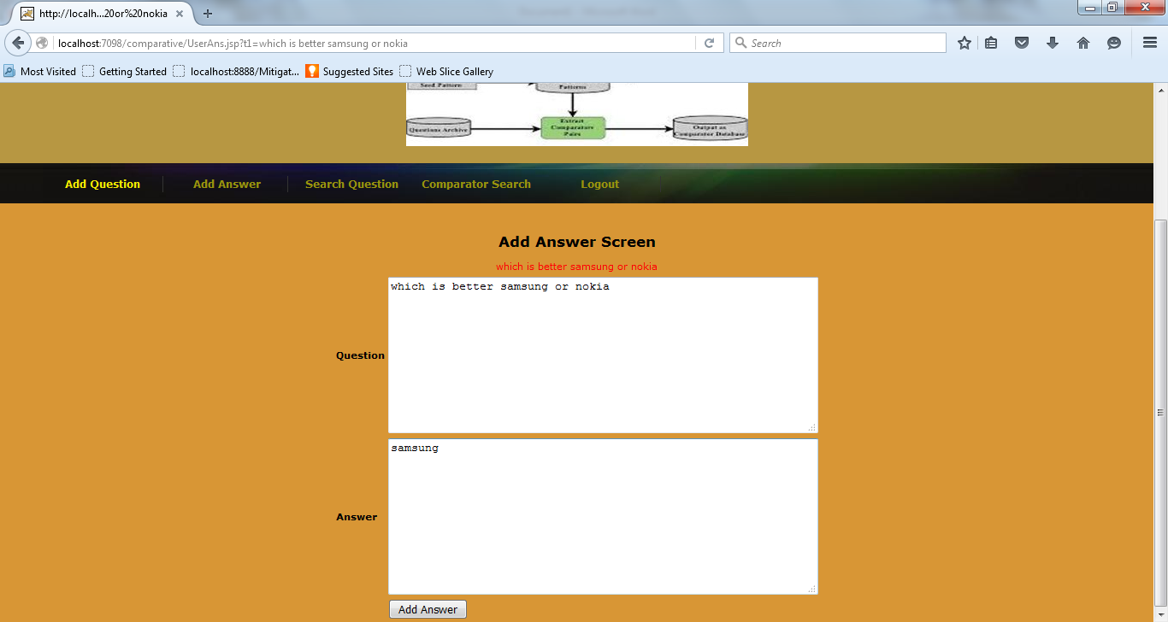

Throwing an error if the question entered by the user is not a comparable one.
Example

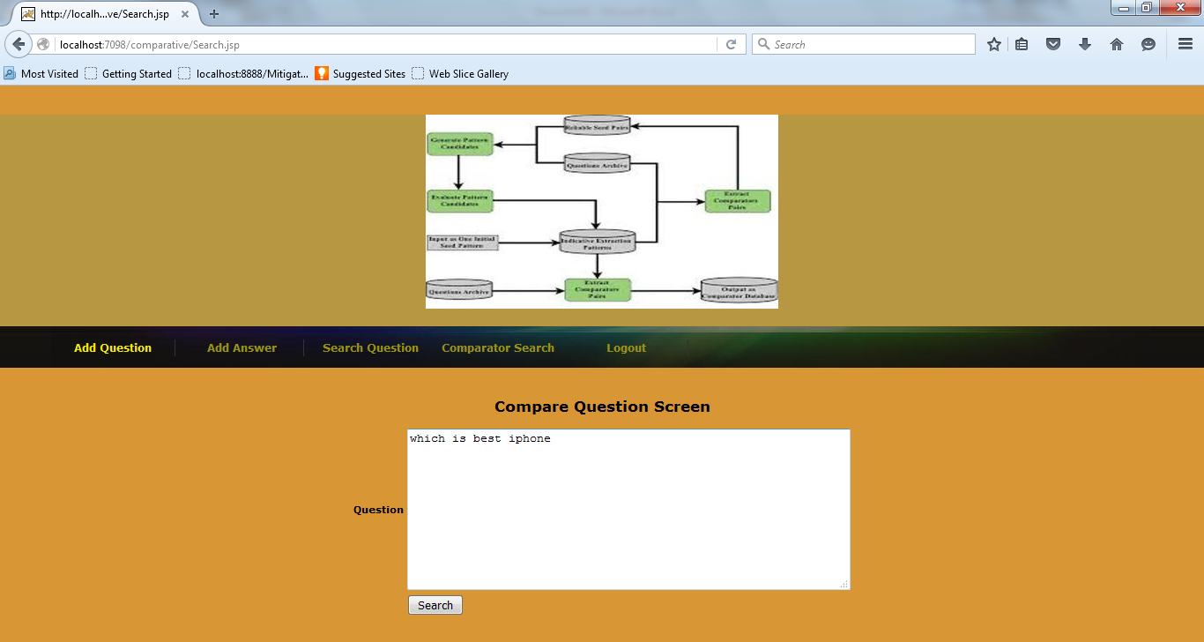

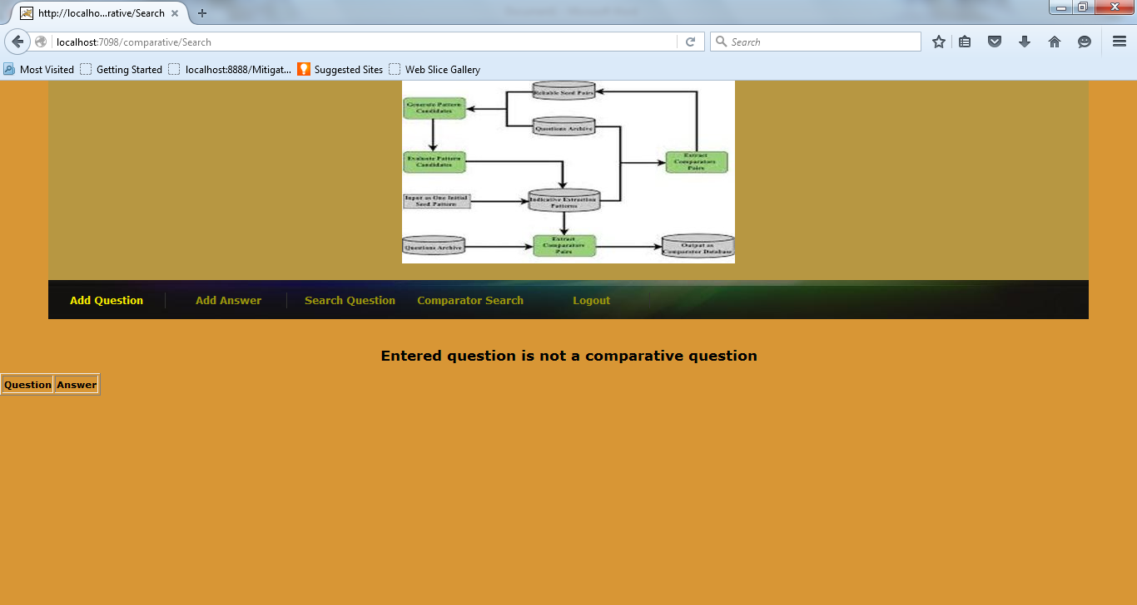

Now search for comparative question

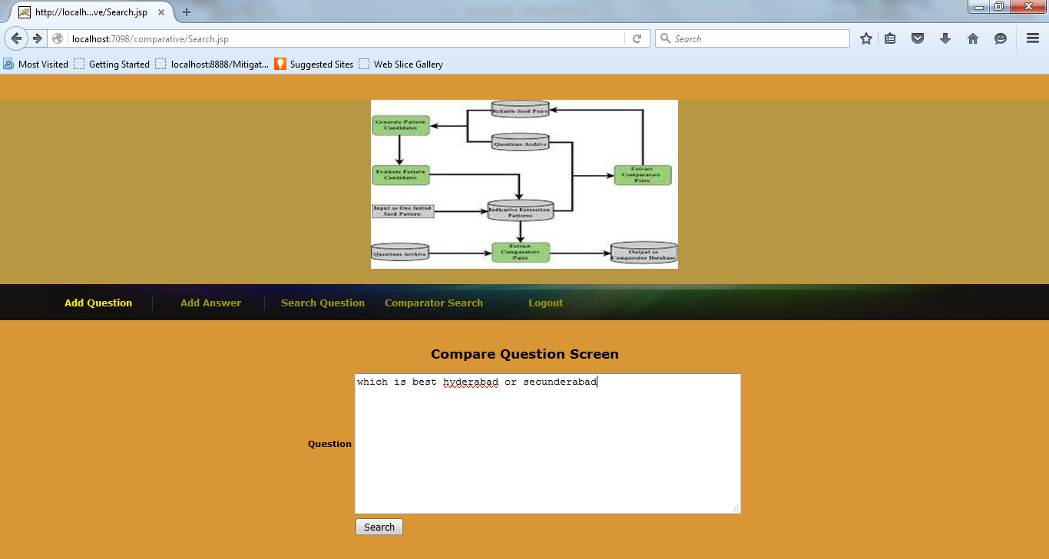

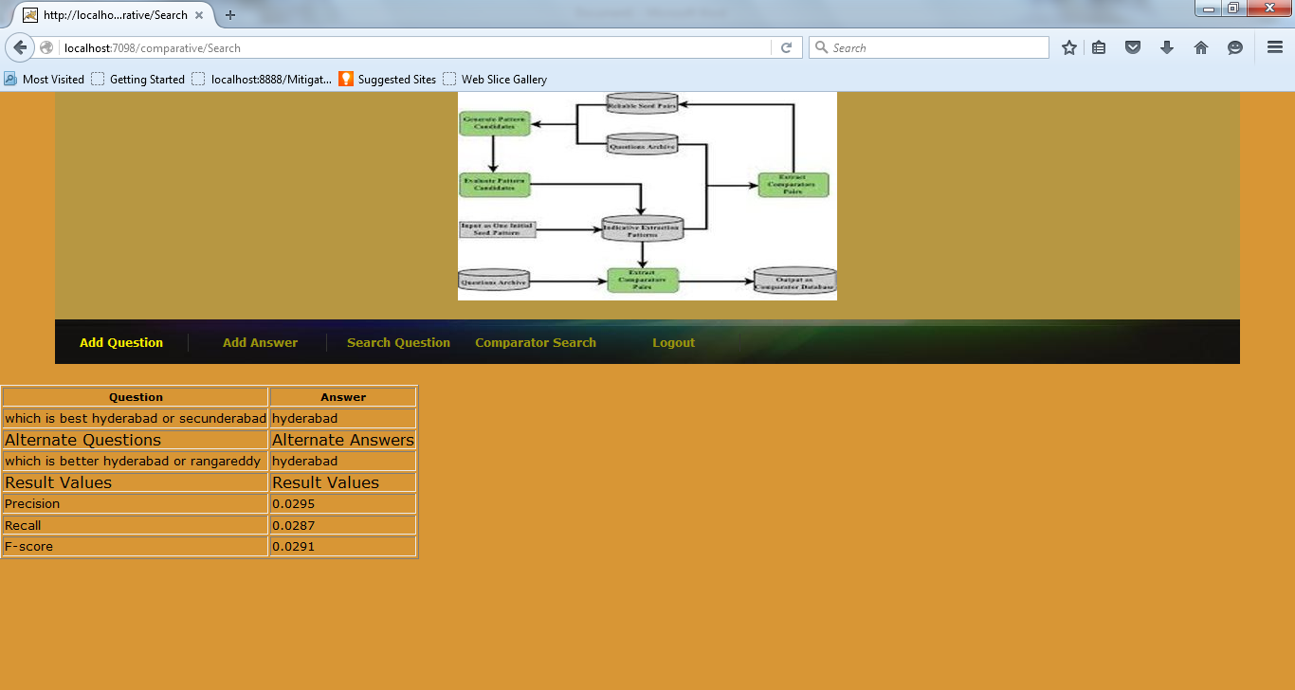

Comparator search example

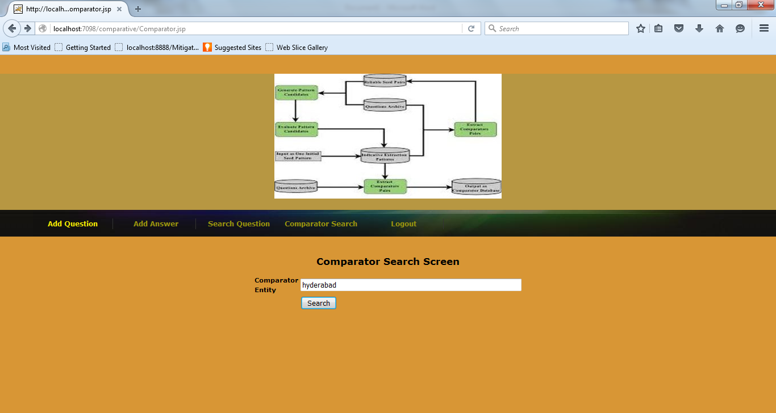

Comparator entity search result

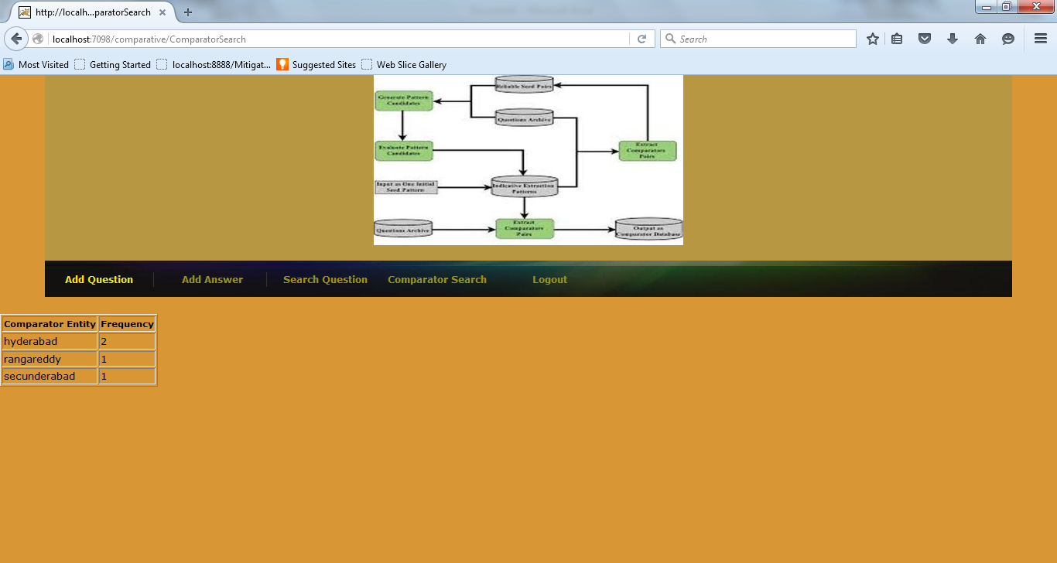

Comparator frequency chart

